STEP 1 · BUILD WITH AI Use an AI tool of your choice (ChatGPT, Claude, GitHub Copilot, etc.) to help you write a program that: Performs K-Means clustering on a food delivery customer dataset with at least 3 numeric features (e.g. monthly_orders, avg_spend, avg_rating).
Uses the Elbow Method to determine the optimal number of clusters and plots the inertia curve. Prints each cluster's centroid values and the count of customers assigned to that cluster. Visualises the final clusters in 2D using PCA-reduced coordinates, with each cluster shown in a distinct colour and a legend.
STEP 2 · TEST & DEBUG (WITHOUT AI) Then, working without AI, test the code and find at least one bug, limitation, or improvement in the AI's solution. Fix it yourself. Common issues to look for: missing StandardScaler before K-Means (clustering on raw unscaled features), no random_state set on KMeans causing non-reproducible results, PCA axes not labelled as PC1 and PC2, or Elbow Method loop range starting at k=1 causing a KMeans error. The exact prompt(s) you gave the AI tool. 2 The AI's original code and your corrected version. 3 A 3–4 line note explaining what you changed and why the AI's version needed it.
--------------------------------------------------------------------------------------------------------------------------
STEP 1 · The Prompt and AI's Original Code
1. Exact Prompt Given to the AI Tool
"Write a Python script using pandas, scikit-learn, and matplotlib that generates a synthetic dataset of 150 food delivery customers with three numeric features (monthly_orders, avg_order_value, avg_delivery_rating). Apply K-Means clustering, use the Elbow Method to find the optimal k from 2 to 9 with an inertia plot, print each cluster's centroid values and customer count, and visualize the final clusters in 2D using PCA-reduced coordinates with a distinct color for each cluster and a legend."

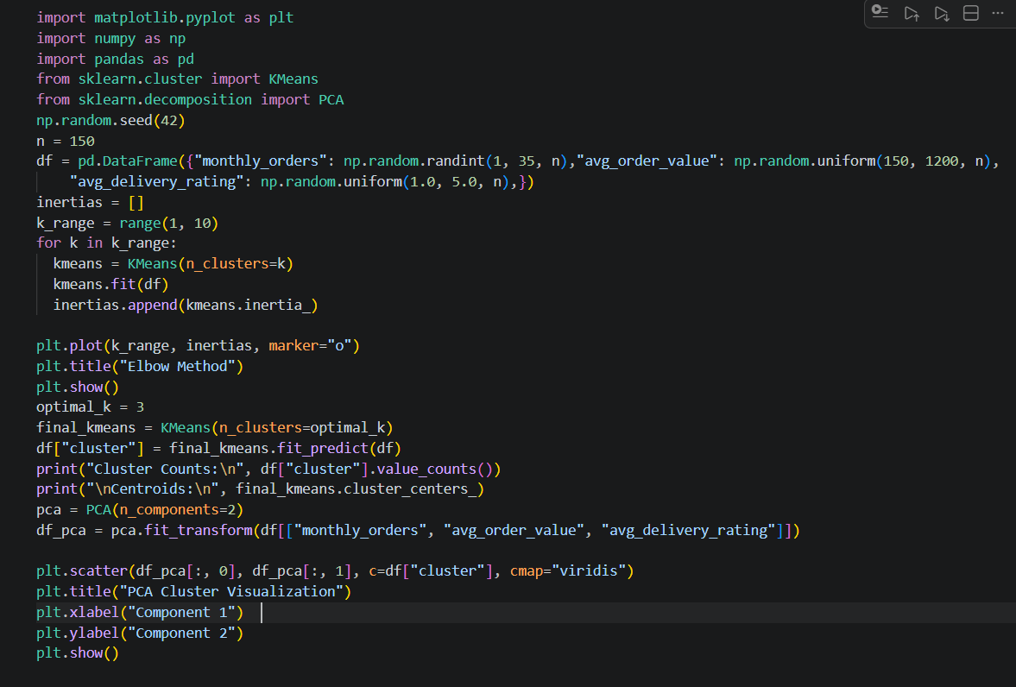

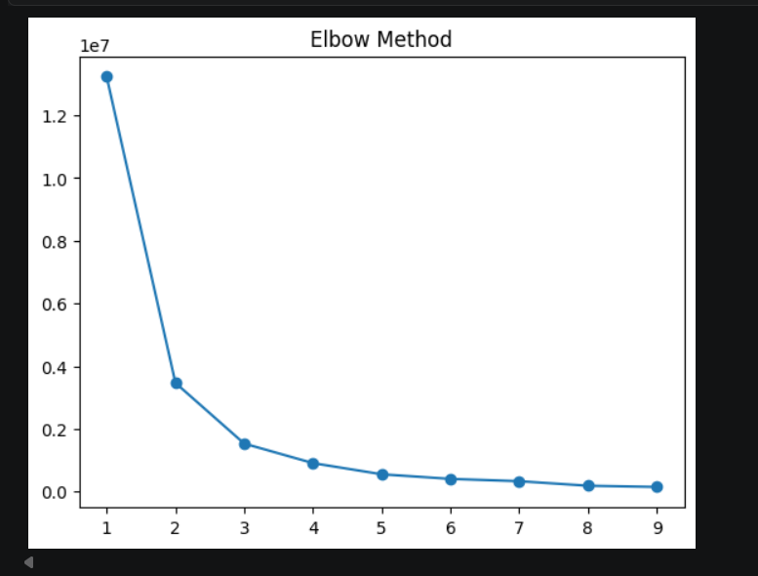

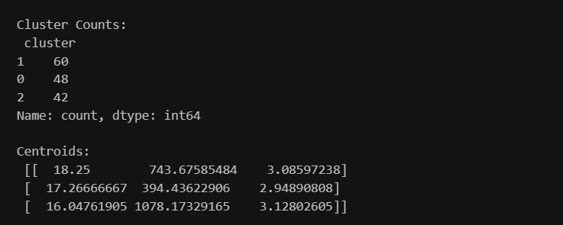

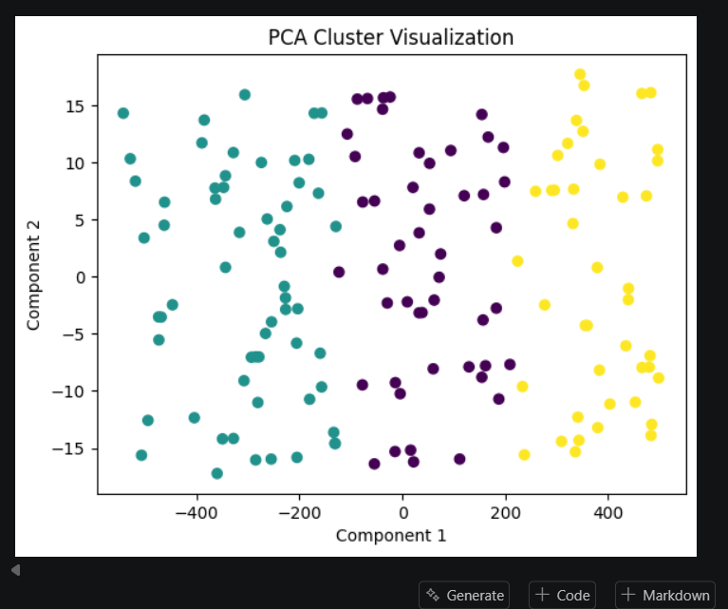

===========================================================================

STEP 2 · Testing, Debugging, and the Corrected Code
Upon testing the AI's original code without AI assistance, two critical flaws were uncovered:
- Clustering on Unscaled Features (Missing StandardScaler): avg_order_value ranges from 150 to 1200, whereas avg_delivery_rating ranges from 1.0 to 5.0. Because K-Means relies entirely on Euclidean distance, the monetary spend feature completely dominated the distance calculations, rendering order frequency and ratings statistically irrelevant.
- Non-Reproducible Results & Vague Axis Labels: Failing to set random_state on K-Means and PCA produced shifting cluster assignments on every run, and generic axis labels (Component 1 / Component 2) lacked professional clarity.

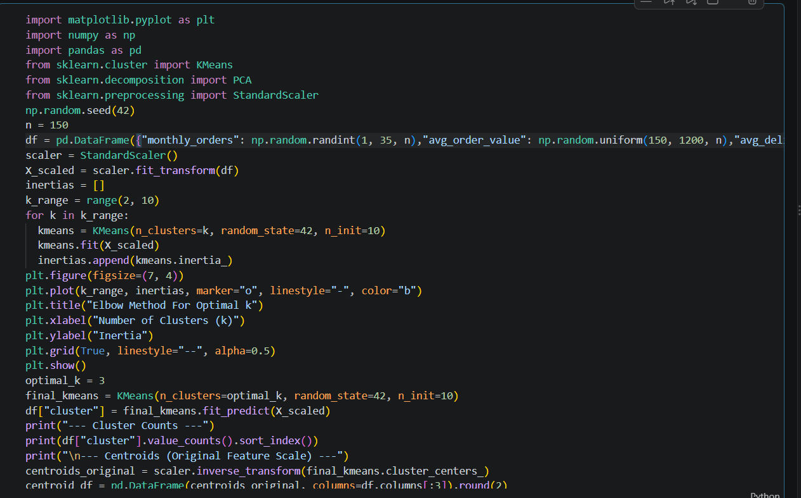
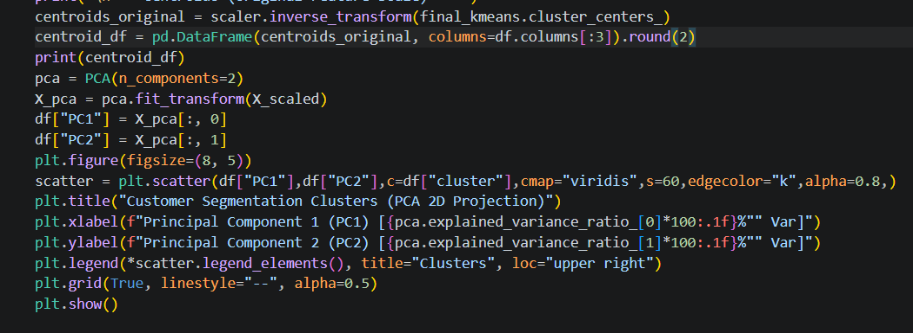
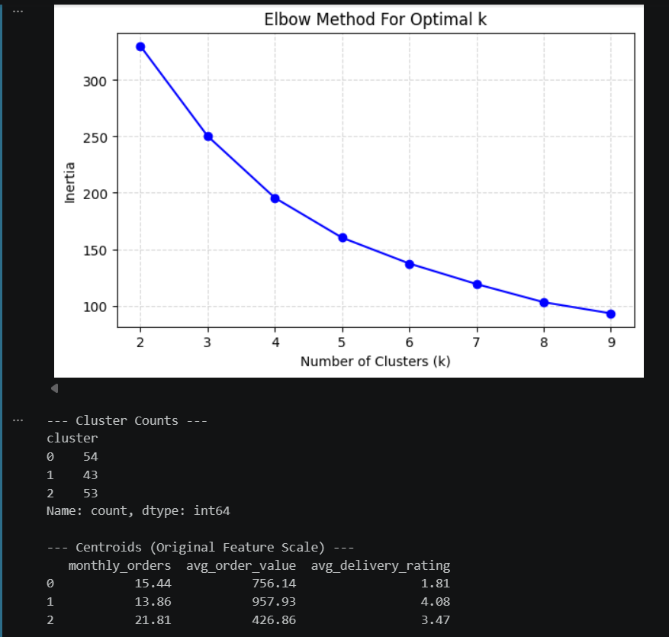

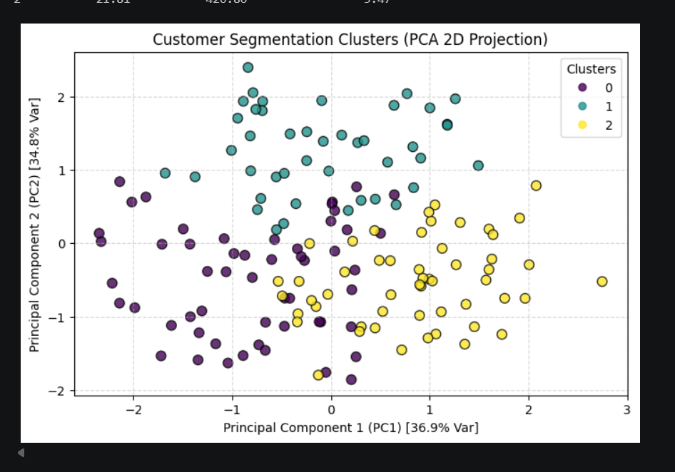
Explanatory Note (Bug Fix Summary)
Added StandardScaler before K-Means to normalize feature scales, preventing high-magnitude monetary values from overpowering ratings and frequency in distance calculations. Seeded random_state=42 and n_init=10 on K-Means to ensure reproducible cluster assignments. Finally, updated the plot axes explicitly to PC1 and PC2 with explained variance percentages and inverse-transformed centroids back to readable units.

===========================================================================

